|  |  |
| --- | --- |
| C:\Users\s.kanakis\AppData\Local\Microsoft\Windows\Temporary Internet Files\Content.Word\ACC Logo_L_rgb_lrg.jpg | **Aranmore Catholic College**  **Semester 2 Examination, 2015**  **Question/Answer Booklet** |

9 SCIENCE

Student Name

#### Time allowed for this paper

Reading time before commencing work: 5 minutes

Working time for paper: 50 minutes

**Materials required/recommended for this paper**

To be provided by the supervisor

This question/answer booklet

***To be provided by the candidate***

Standard items: pens, pencils, eraser, correction fluid, ruler.

**Important note to candidates**

No other items may be taken into the examination room. It is **your** responsibility to ensure that you do not have any unauthorised notes or other items of a non‑personal nature in the examination room. If you have any unauthorised material with you, hand it to the supervisor **before** reading any further.

**SECTION A: MULTIPLE CHOICE (36 marks)**

*Please circle or put a cross through your selection.*

1. A B C D 21. A B C D

2. A B C D 22. A B C D

3. A B C D 23. A B C D

4. A B C D 24. A B C D

5. A B C D 25. A B C D

6. A B C D 26. A B C D

7. A B C D 27. A B C D

8. A B C D 28. A B C D

9. A B C D 29. A B C D

10. A B C D 30. A B C D

11. A B C D 31. A B C D

12. A B C D 32. A B C D

13. A B C D 33. A B C D

14. A B C D 34. A B C D

15. A B C D 35. A B C D

16. A B C D 36. A B C D

17. A B C D

18. A B C D

19. A B C D

20. A B C D

*Make a choice of answer and mark it with a cross on the multiple choice answer grid.*

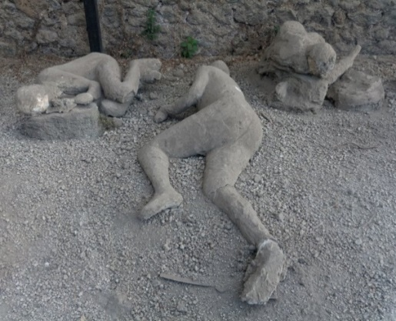

1. To the right are casts of people who died in Pompeii after the eruption of Mt Vesuvius. We can see these today because:

(a) The lava preserved the bodies.

(b) The lava formed a protective rock casing.

(c) The ash turned to rock around the bodies.

(d) The bodies turned to stone.

2. Many years ago the main continents of the Earth were joined in one large land mass called:

1. Pangaea.
2. Patagonia.
3. Gondwanaland.
4. Laurasia.

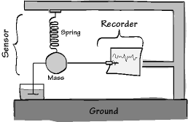

3. The diagram on the right shows a devise used to measure the strength of an earthquake. It is called a:

1. Richter scale.
2. Sensor meter.
3. Seismometer.
4. Volcanometer.

4. Which of the following is **INCORRECT** about magnetic striping:

(a) bands of alternating magnetism were discovered by the navy during world war II.

(b) the bands of alternating magnetism are asymmetrical (has two sides that don’t match).

(c) magnetic striping led to the conclusion that the magnetic poles of the Earth changes every few million years.

(d) the bands run parallel to mid-ocean ridges.

5. Which of the following statements is correct?

(a) Tsunamis involve a lot of moving water, but not a lot of energy.

(b) Tsunamis are only dangerous when they reach a coastline.

(c) Tsunamis are caused by underwater volcanoes.

(d) Tsunamis are caused by wind.

6. Earthquakes and volcanoes are often found together because:

(a) They are both produced by movement of the crustal plates.

(b) Earthquakes cause volcanoes.

(c) Both are formed in the same way.

(d) Volcanoes cause earthquakes.

**Questions 7, 8 and 9 refer to the diagram on the right.**

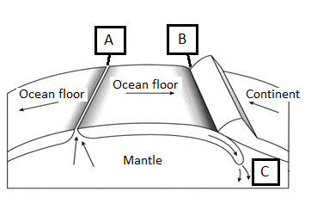

7. Label C represents the process of:

(a) Volcanic eruption.

(b) Seafloor spreading.

(c) Regression.

(d) Subduction.

8. Select the location where an ocean ridge would form.

(a) A.

(b) C.

(c) B.

(d) Both A and B.

9. Select the location where a deep sea trench would form.

(a) C.

(b) A.

(c) Both A and B.

(d) B.

10. Select the correct definition for the term ‘magma’.

(a) Magma is a rock that has solidified from molten rock.

(b) Magma is molten rock that has flowed out onto the Earth’s surface.

(c) Magma is molten rock under the surface of the Earth.

(d) Magma is an igneous rock such as granite.

11. Which of the following is an example of a solid rock thrown out by an erupting volcano.

(a) Scoria.

(b) Coal.

(c) Lava.

(d) Hydrogen sulfide.

12. The concept of continental drift was first suggested by:

(a) Wegener.

(b) Wagner.

(c) Wallace.

(d) Watanabe.

13. At the San Andreas Fault, two plates slide past one another, this is an example of a:

1. Transform boundary.
2. Converging boundary.
3. Diverging boundary.
4. Subduction boundary.

14. The Red Sea has been caused by two tectonic plates moving apart, this is an example of a:

1. Transform boundary.
2. Converging boundary.
3. Diverging boundary.
4. Subduction boundary.

15. The process of subduction occurs along:

1. Transform plate boundaries.
2. Converging plate boundaries.
3. Diverging plate boundaries.
4. Subduction plate boundaries.

Question 16 and 17 refer to the photo below:

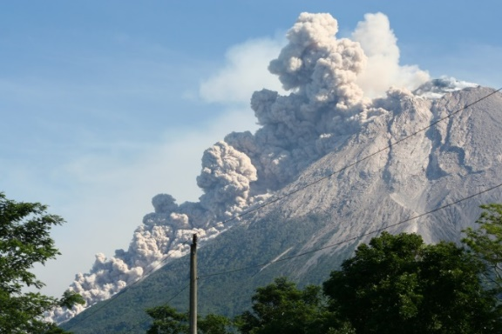16. The photo on the right shows a cloud of ash rock and gas rushing down the side of Merapi Volcano in Indonesia.

This is known as:

(a) an ash cloud.

(b) pyroclastic flow.

(c) lava.

(d) magma.

17. Which of the following is **INCORRECT** about this phenomenon?

(a) It is very dangerous because it travels very fast.

(b) It is less dangerous to nearby residents than lava.

(c) It doesn’t occur with every volcanic eruption.

(d) It can be very hot, around 500oC.

**The diagram below is used to answer question 18.**

|  |  |
| --- | --- |
| Before Earthquake | During Earthquake |
|  |  |

18. The diagram shows a method of earthquake proofing a building known as:

(a) Damping.

(b) Flexing.

(c) Rigidity.

(d) Base isolation.

19. One advantage of living near a volcano is:

(a) fertile soil.

(b) good water drainage.

(c) warm weather.

(d) clean air.

20. During subduction:

(a) the plate which is sliding over the top of the lower plate becomes magma.

(b) the plate that is sinking under the other plate starts to melt.

(c) the magma between the two plates flows out, producing rift valleys.

(d) the plate which is sliding over the top of the lower plate starts to melt.

21. Which of the following was **NOT** used by Wegener as evidence of continental drift?

(a) The fact that the same fossils were found in different continents.

(b) The fact that the continents that these same fossils were found in are now far apart.

(c) Magnetic striping.

(d) The fact that some continents seemed to fit together like the parts of a jigsaw.

1. 22. Rifting is the process of:

(a) ocean trenches forming by collisions of plates.

(b) the crust subducting.

(c) plates moving by sliding past each other.

(d) the crust cracking and subsiding.

23. Chains of volcanic islands in the sea called an ‘island arc’ provided evidence of which particular

process?

(a) Rifting.

(b) Sea-floor spreading.

(c) Subduction.

(d) Transform boundaries.

24. Seismic waves can be used to determine the:

(a) Speed of plate movements.

(b) Rate of sea-floor spreading.

(c) Structure of the Earth.

(d) Depth of the ocean-trenches.

25. Eastern Australia has some extinct volcanoes. The oldest are in Queensland and they become

progressively younger all the way down to southern Victoria. The nearest plate boundaries are

thousands of kilometres away. Identify which of the following is a likely explanation for these

volcanoes.

(a) They were formed by subduction at a collision boundary along the east coast

(b) They were formed by rifting of the crust along the east coast

(c) They are hot spot volcanoes from the hot spot of Victoria

(d) A new transform boundary is forming along the east coast.

1. 26. Consider the following table:

|  |  |  |
| --- | --- | --- |
| **Pair of plates** | **Type of boundary** | **Rate of movement (cm/yr)** |
| Australian/Antarctic | Diverging | 6.5 in west, 7.5 in south, 6.8 in east |
| Pacific/Nazca | Diverging | 17.6 |
| Pacific/Antarctic | Diverging | * 1. in west up to 10.2 in north |

What can you conclude from this data?

(a) All parts of a plate move at the same rate

(b) Different plates move at the same rate

(c) Plates at a diverging boundary move much faster than plates that are colliding

(d) The same plate can move at different rates along its boundary

27. The layers of the Earth, in correct order from the center outwards are:

(a) inner core, outer core, lithosphere, mantle.

(b) inner core, outer core, asthenosphere, lithosphere.

(c) inner core, mantle, crust, asthenosphere.

(d) inner core, outer core, mantle, lithosphere.

28. The asthenosphere is a layer found in the:

(a) crust.

(b) mantle.

(c) outer core.

(d) lithosphere.

29. Why does Australia have no active volcanoes and rarely experiences earthquakes?

(a) Because Australia lies over diverging and converging boundaries.

(b) Because Australia is found in the middle of a tectonic plate.

(c) Australia is surrounded by only diverging boundaries.

(d) Australia is surrounded by only converging boundaries.

30. Which type of seismic wave/s causes the most destruction?

(a) Primary waves (P waves).

(b) Secondary waves (S waves).

(c) Surface waves.

(d) Tectonic waves.

31. Select the correct colour change that magma undergoes as it cools.

(a) Black, red, yellow, orange, white.

(b) Yellow, white, orange, red, black.

(c) White, yellow, orange, red, black.

(d) White, orange, yellow, red, black.

32. What material would **NOT** be found in volcanic eruption?

(a) Water vapour.

(b) Ash.

(c) Scoria.

(d) Slate.

1. **The following information is for questions 33 to 35.**
2. Consider the following map showing the positions of two GPS ground stations near the city of San Francisco in California, USA. One station is on the Farallon Islands on the Pacific Plate. The other station is east of the Farallon Islands. It is in the city of Columbia, on the North American Plate. The graph shows the direction of movement of the two stations against each other. The horizontal line on the graph shows movement in a westerly direction.

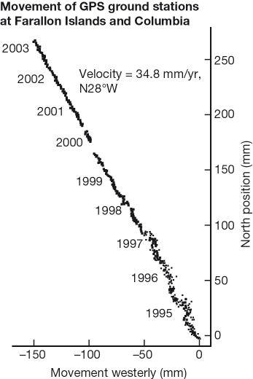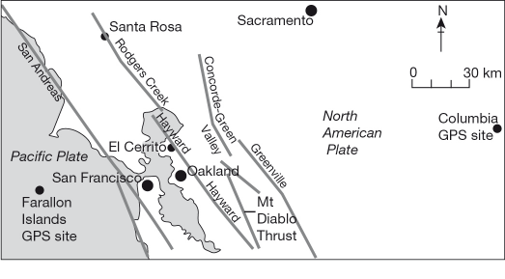

33. What approximate direction does the California coast run?

(a) North-west

(b) North

(c) East

(d) South-west

34. The graph supports the view that:

(a) The Pacific Plate is moving towards the North American Plate

(b) There is a collision boundary between the Pacific Plate and the North American Plate

(c) A rift is opening between the Pacific Plate and the North American Plate

(d) There is a transform boundary between the Pacific Plate and the North American Plate

35. The information in the map and the graph shows:

(a) Subducting plates can be measured by GPS ground stations

(b) GPS ground stations can measure both the speed and direction of plate movements

(c) GPS ground stations can predict when a fault line is going to slip

(d) Earthquakes and volcanic eruptions can be predicted by using GPS ground stations

36. Select the correct definition for the term ‘epicenter’.

1. The origin of the earthquake directly below the focus.
2. The tectonic plate which moves causing an earthquake.
3. A point in a nearby city which receives the most damage as a result of the earthquake.
4. The point on the Earth’s surface directly above the focus of an earthquake.

**SECTION B SHORT ANSWER QUESTIONS (14 marks)**

**1.** Match the terms to their statements by writing the number of the correct statement in the box. (5 marks)

|  |  |  |  |
| --- | --- | --- | --- |
|  | **TERM** |  | **STATEMENT** |
|  | Primary waves (P-waves) | 1. | A receiver and computer located on tectonic plates around the world that measure the rate of plate movement. |
|  | Epicenter | 2. | Structures that move in opposition to the waves caused by earthquakes and oppose their effect. |
|  | Hotspots | 3. | Longitudinal waves that travel fast through the Earth. |
|  | Dampers | 4. | A layer of “plastic” semi-solid rock in the upper mantle. |
|  | Secondary waves (S-waves) | 5. | The term given to sticky and slow flowing lava. |
|  | Viscous | 6. | The point on the Earth’s surface, directly above the focus of an earthquake. |
|  | Pyroclastic flow | 7. | An area in Eastern Africa where the land is subsiding. |
|  | Asthenosphere | 8. | Isolated places where a lot of magma is being produced. |
|  | GPS ground station | 9. | Transverse waves that travel through the Earth. |
|  | Great Rift Valley | 10. | Clouds of ash, rock and gas that rush down a volcano like an avalanche. |

**2.** Below are three diagrams. Use the words below to label them. Only use each word once.

(9 marks)

*Pyroclastic flow, magma chamber, ash cloud, central vent, lava,*

*magma, volcanic bombs, side vent, crater*

